COUNTY COUNCILLOR REPORT
TO
ALL PARISH COUNCILS
IN PETERSFIELD HANGERS

2 SEPTEMBER 2024
- Solar Together scheme returns!

The solar energy group-buying scheme promoted by Hampshire County Council is now in its third offer. Managed by independent experts iChoosr, the scheme enables residents to invest in solar panels for their homes, fitted by pre-vetted installers. This can reduce reliance on the national grid and lower energy bills, as well as tackling climate change.

We would be very grateful for your support in promoting the scheme via your newsletters and social media channels please.

Through Solar Together, over 28,400 solar panels have already been installed in Hampshire. It is estimated that these installations alone will reduce carbon emissions by 59,205 tonnes over 25 years – equivalent to taking over 32,600 cars off the road during the same period.

Those interested need to register online at www.hants.gov.uk/solartogether by 18 October 2024 for a free and without obligation quote.

The scheme offers Hampshire homeowners a hassle-free way to make the switch to clean energy, ensures installation is cost effective and gives residents confidence in their decision. Registering your interest allows you to take advantage of the benefits of the scheme without committing to any agreement or purchase.

Participants who register will receive a complimentary quote that demonstrates their potential savings on energy bills through solar panel installation. They can also learn about the opportunity to earn extra income by selling excess energy to the National Grid. Additionally, participants have the flexibility to choose to include battery storage or electric vehicle charge points at the time of registration or when they accept their offer.

To participate in the Solar Together scheme, residents need to own the property or have permission from the property owner to install a solar system on the roof. Small- and medium-sized businesses and Commonhold Associations that meet these requirements can also participate.

- Devolution in Hampshire

You may have seen reports in the local press about the possibility of a devolution deal for Hampshire. The new Leader of HCC Nick Adams-King has been meeting regularly with Unitary Authority Leaders from Portsmouth, Southampton and the Isle of Wight as well as the Leaders of all Districts and Boroughs in Hampshire. These discussions have been positive and an Expression of Interest was submitted to the Government last week.

The Secretary of State in charge of Local Government is now Deputy Prime Minister Angela Rayner MP. She has written to the Leader of Hampshire County Council and in that letter she has indicated the Government’s intention to push ahead with a devolution deal for Hampshire. It is envisaged that this would be a pan-Hampshire deal.

The Secretary of State acknowledges that many areas have struggled to get devolution settlements over the line. The Government has promised to work with Hampshire to resolve those issues. A new National Devolution framework is expected to be published by the Government before the end of the year. We will need to scrutinise this carefully.

I believe that all local leaders in Hampshire appreciate that more powers and more funding have the potential to bring benefits for growth, skills, placemaking and frontline services in our great County. Resolving some of the current funding shortages will also bring benefits to Parish and Town Councils. I will continue to update you on developments.

- Road repair update

Hampshire County Council has been hard at work fixing potholes and road defects.
From April 2023 to April 2024, we delivered a whopping 180,909 repairs – a 37% increase from the previous year.

Colder, wetter winters take a toll on roads everywhere. Plus, inflation means it now costs taxpayers around 44% more to repair a pothole. Nevertheless, thanks to an additional £22.5 million investment over two years, our highways service and main contractor, Milestone, have been able to deploy more resources to tackle these road issues promptly. Over £10m from the scrapped HS2 route is also now available to be spent on Hampshire roads.

I think we are all acutely aware that the wet Summer has led to a lot of vegetation growth. In places, this impacts visibility and road safety. I am including a link below to the web page where you can report these vegetation visibility issues:

https://www.hants.gov.uk/transport/roadmaintenance/roadproblems/treehedge

Your support in flagging up these issues is much appreciated.

- Love Lane Space for Nature

I would like to report on a project to improve biodiversity and reduce anti-social behaviour at the wood opposite the community centre, which I am calling “Love Lane Space for Nature”. This land is owned by HCC and is also known as Land at Tor Way. See below image for location.

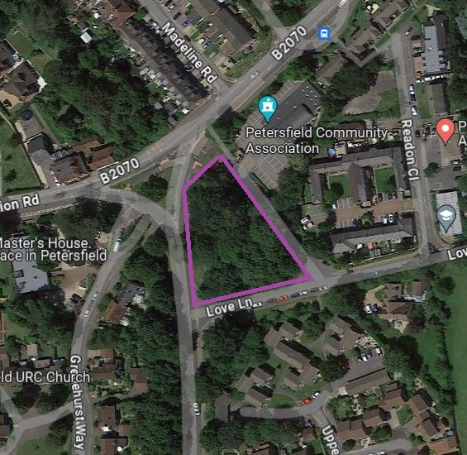

As a former railway sidings, the site has heritage significance. But the site has been effectively abandoned since the Beeching cuts in 1960. The wooded area has become impenetrable as well as being a magnet for fly-tipping and drug-taking. Cherry laurel has regrettably proliferated; this is an invasive tree which poisons the soil because its berries and leaves contain a form of cyanide called prussic acid. It therefore poses a risk to native trees and to biodiversity generally.

A coalition of volunteers led by the Hampshire Monday Group has now come together with a view to removing the cherry laurel over the winter period. The objective is to protect the native trees and improve biodiversity by allowing more light into the wood. This project has support from HCC, EHDC and SDNPA. I hope that PTC will also agree to support the project. The volunteer coalition includes Hampshire Monday Group, Petersfield Men’s Shed, Petersfield Community Association, the Physic Garden’s Head Gardener and local residents on Love Lane.

Once the cherry laurel has been removed, the next stage of the project will be to undertake a habitat assessment and a biodiversity assessment. I am already in touch with the County Botanist about that. Once those assessments are done, consideration can be given to whether some limited access to the wood for people can be encouraged and facilitated in the future.

There may be remnants of the Midhurst Line which are unearthed during the winter works. If so, that could be interesting and I will involve all stakeholders (including the museum) in considering the best way to document and preserve the heritage features.

- County Farms opportunities

I think it is really great that Parish Councils in Petersfield Hangers have such strong links to the farming community in your areas. Many of you also know young people who have been to Sparsholt College to develop farming skills.

I therefore thought it was worth sharing the list of farms currently available through HCC’s County Farms scheme. These campaigns are generally run every 2-3 years. See below graphic:

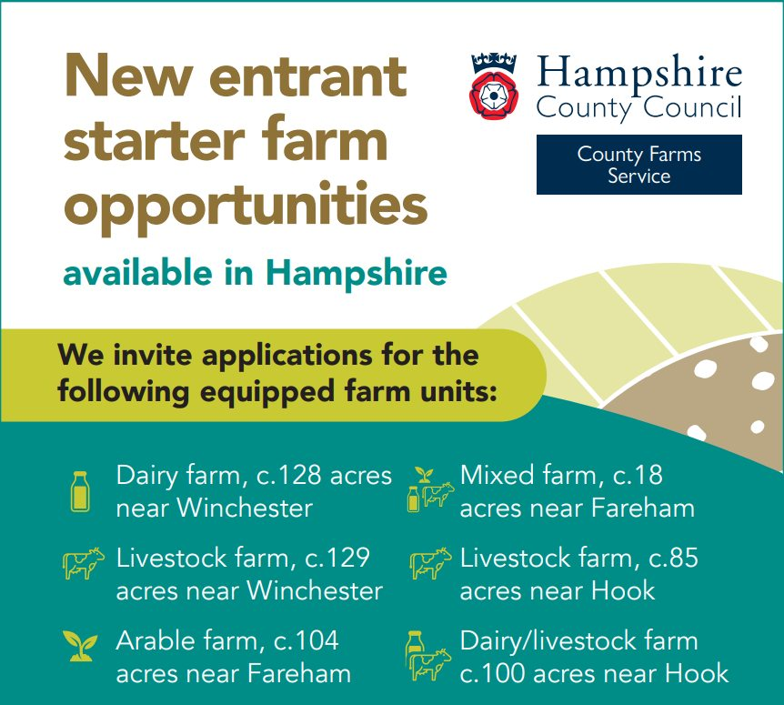

To find out more about how to apply, just go to www.hants.gov.uk/countyfarms

Hampshire is not unique as a county in offering County Farm opportunities to new farmers, but have one of the most extensive county farm projects in the country, of which Hampshire County Council is rightly proud.

- Hampshire Childrens Services rated Outstanding again

Supporting children and young people to get the best possible start in life and protecting those who are most vulnerable is one of our top priorities, so we’re pleased to share that our Children’s Services have once again been rated ‘Outstanding’ by Ofsted – the second time in a row.
Hampshire children and families who need extra help and protection continue to be supported by one of the few authorities in the country with outstanding rated Children’s Services. Our dedicated staff continue to make a positive difference, despite the backdrop of growing demand and complexity in the needs of children.
Click on this link to learn more: https://www.hants.gov.uk/.../20240723outstandingofstedresult

- South Downs Food Festival

The South Downs Food Festival will take place over the weekend of 14 and 15 September within the grounds of Stansted Park, near Rowlands Castle.

Visitors can browse the South Downs Market, which will feature artisan producers from across the region, and there will be an opportunity to try out local wines, beers, and gins. Activities will include a chef’s table, apple pressing, ice cream making and how to build an outdoor oven.

Dame Prue Leith will be examining Elizabeth David’s long-term influence on British food. Diane Purkiss, historian and author of English Food (2022), will speak about Elizabeth David’s historical significance alongside the writer Rachel Cooke.

Find out more and book tickets at www.southdownsfoodfestival.com

RUSSELL OPPENHEIMER
County Councillor for Petersfield Hangers

